2023EBCS153
Ibrahim Yerima Balla
Software Development Practices

Question One.

I created the porject folder locally and initialized a git repo in it using git init command.
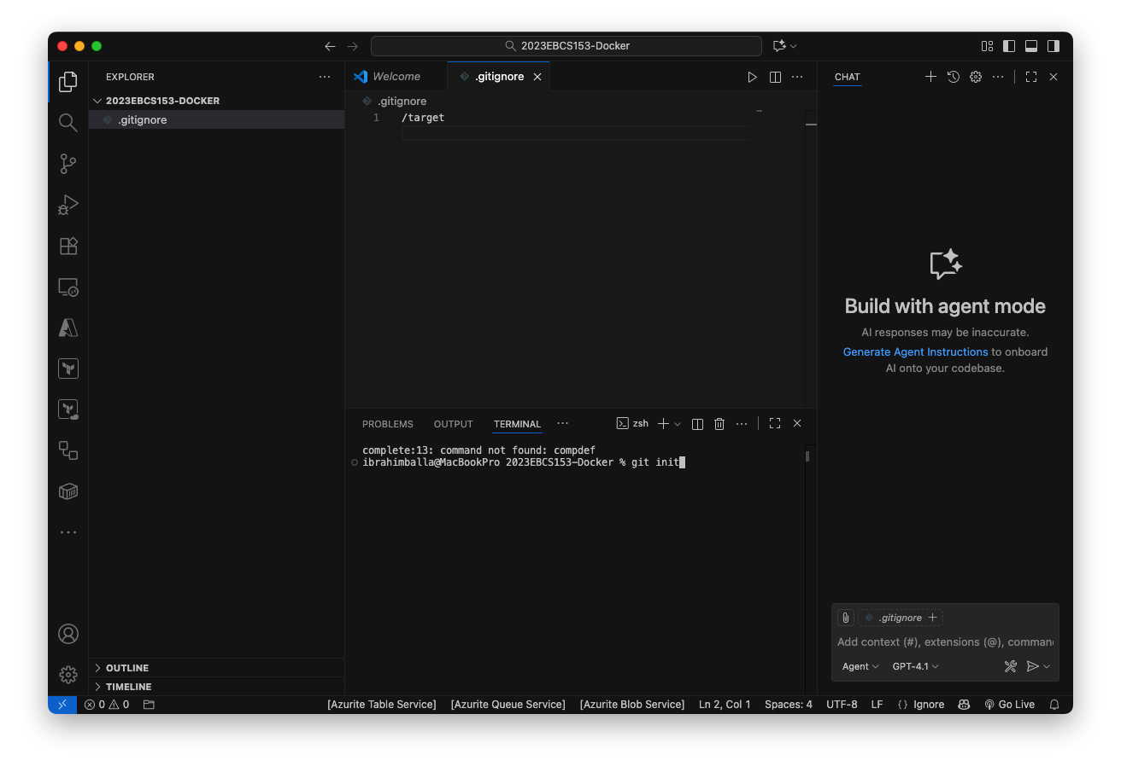
I then added two html pages index.html and contact.html which is just a profile page about myself. At this momment these two files are in the working directory and to move them to the staging area I simply used git add * which included all of the files , I could have added them individually using the file name like so git add index.html.

b) To integrate my local git repository into GitHub, I created a git repository in my account Here. I then add the remote repo to my local repository so that it can push to the remote repository. To do that I simply used the command git remote add origin git@github.com:ibrahimballamsf/2023EBCS15-Docker.git

I then pushed all the changes I made by first committing with git commit -m “Initial commit” and git push origin main
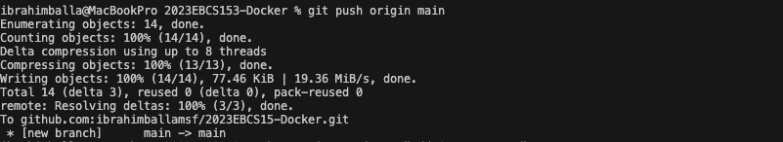

To create a branch, I used the command git branch <BRANCH_NAME>
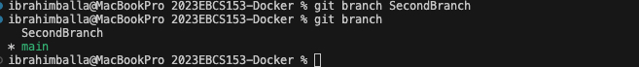

Using git log, I can view the commit history in my currently checkout git branch as shown in the image below:
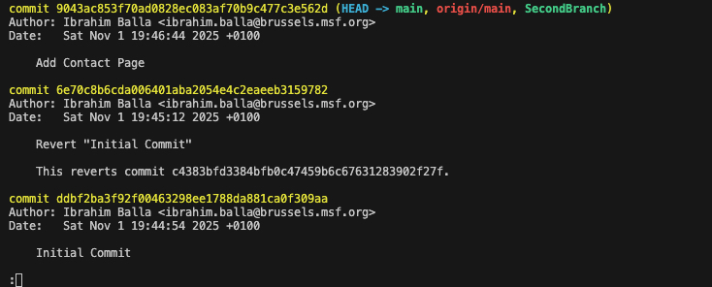

Using git status, I can view the status of the working directory
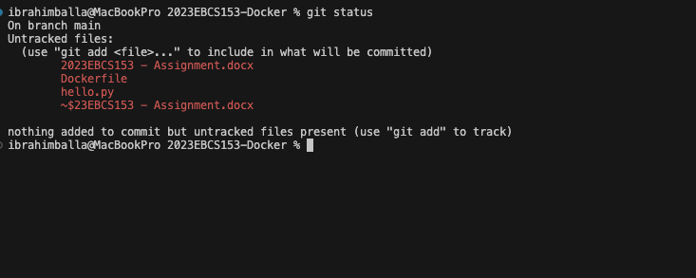

Question Two:
I created the Dockerfile which is based on python 3.12 image and added a python file that prints out hello world when executed.

FROM python:3.12-slim

WORKDIR /app

COPY hello.py .

CMD ["python", "hello.py"]

print("Hello, World!")

To build and push the image to dockerhub, I first logged into docker hub using the command docker login
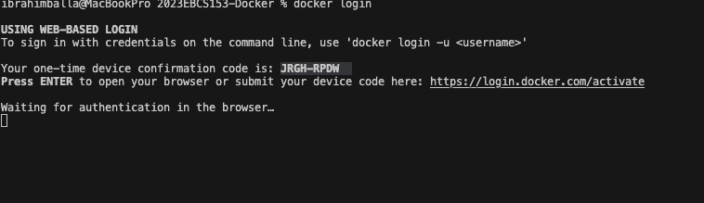

I built and tagged the docker image using the command docker build -t ibrahimballa20/hello-python:latest .
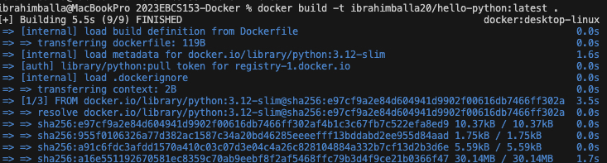

I then pushed the image to my account in dockerhub(ibrahimballa20) using the command
docker push ibrahimballa20/hello-python:latest

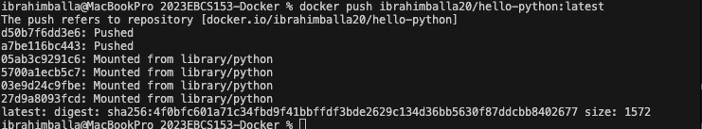

Finally, I was able to run the docker image using the command docker run ibrahimballa20/hello-python:latest

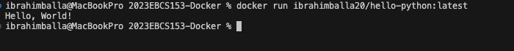

It printed hello-world to the screen and exited the container as expected.

Summary
This assignment provided hands-on experience with two key DevOps practices, version control using Git and GitHub and containerization using Docker. I successfully created a local Git repository, initialized a simple web project with two HTML pages, and demonstrated key Git commands such as init, add, commit, branch, switch, and log. The repository was then linked to GitHub and pushed successfully, demonstrating integration between the local and remote repositories.
In the Docker component, I built a Docker image for a basic Python “Hello World” application, documented the build process, and pushed the image to Docker Hub. I also ran the container locally to confirm proper functionality.

